SPRITN-I

SETTING UP APPLICATION ENVIRONMENT

Create An IBM Cloud Account:

The Instructions video given in the Dashboard by IBM smartinternz.com. we have created an IBM Cloud account for sets the environment to the develop a Nutrition Assistant Application.

Here we attached the Screenshots that has created.

Pooja(Teamleader)

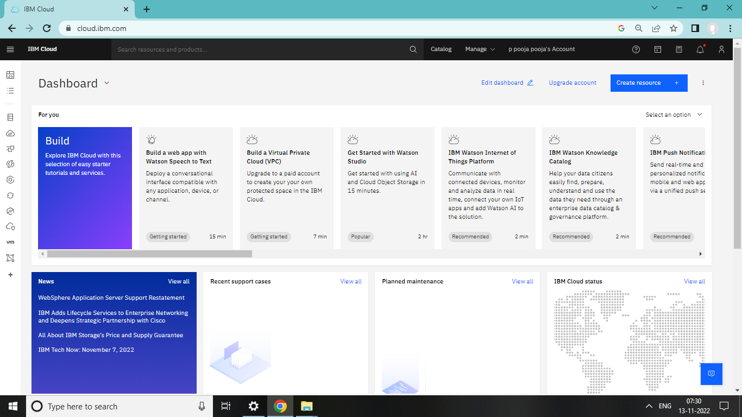

Thilagavathi N

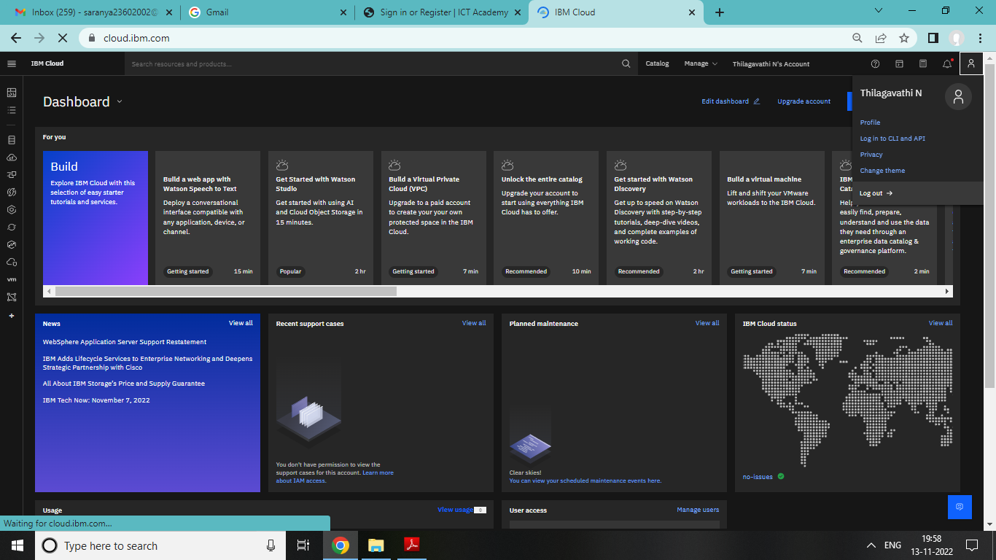

Sivatharani

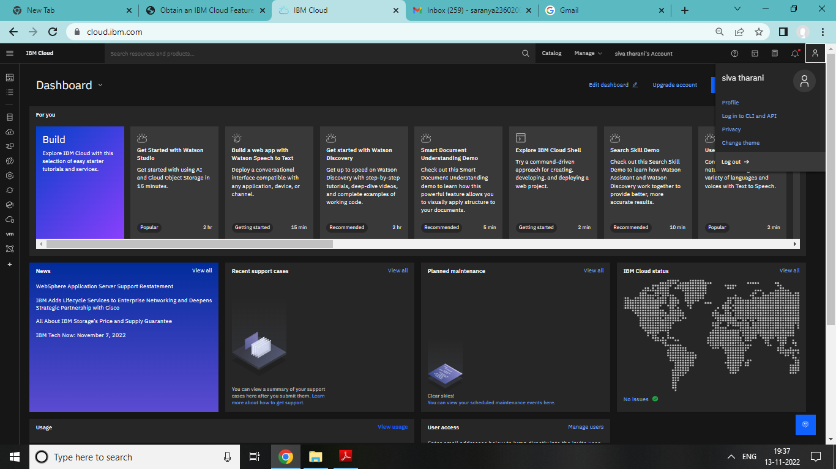

Maharaja

